# **API**

# What is an API ?

* **It is a software interface that allows two applications to interact with each other without any user intervention. API is a collection of software functions and procedures.**
* **API is defined as a code that helps two different software’s to communicate and exchange data with each other.**
* **It offers products or services to communicate with other products and services without having to know how they’re implemented.**

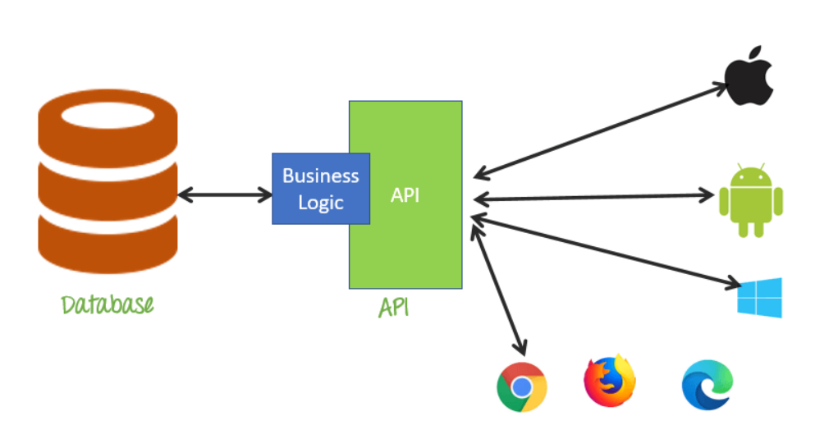

**Real world example :-** Restaurant order, meesho order.

**Representational State Transfer (REST)** is an architectural style for an application program interface (API) that uses HTTP requests to access and use data.

**Working:** A request is sent from client to server in the form of a web URL as HTTP GET or POST or PUT or DELETE request. After that, a response comes back from the server in the form of a resource which can be anything like HTML, XML, Image, or JSON.

**Difference between API & REST API**

An API, or application programming interface, is a set of rules that define how applications or devices can connect to and communicate with each other. A REST API is an API that conforms to the design principles of the REST, or representational state transfer architectural style.

**HTTP (Hypertext Transfer Protocol)** specifies a collection of request methods to specify what action is to be performed on a particular resource.

**Example :-** Zomato uses google map api, geekster uses google login api, cowin api.

**Different kinds of HTTP requests**

The most commonly used HTTP request methods are GET, POST, PUT, PATCH, and DELETE. These are equivalent to the CRUD operations (create, read, update, and delete).

1. **GET -** It is used to read/retrieve data from a web server. GET returns an HTTP status code of **200** (OK) if the data is successfully retrieved from the server.
2. **POST -** It is used to send data (file, form data, etc.) to the server. On successful creation, it returns an HTTP status code of **201**.
3. **PUT -** It is used to modify the data on the server. It replaces the entire content at a particular location with data that is passed in the body payload. If there are no resources that match the request, it will generate one.
4. **PATCH -** It is similar to PUT request, but the only difference is, it modifies a part of the data. It will only replace the content that you want to update.
5. **DELETE -** It is used to delete the data on the server at a specified location.

# Postman

* What is Postman ?
* Installation ?
* How to use it ?
* Body, header, url

## Introduction to Postman

* **Postman is a standalone software testing API (Application Programming Interface) platform to build, test, design, modify, and document APIs. It is a simple Graphic User Interface for sending and viewing HTTP requests and responses.**
* **While using Postman, for testing purposes, one doesn't need to write any HTTP client network code. Instead, we build test suites called collections and let Postman interact with the API.**
* **In this tool, nearly any functionality that any developer may need is embedded. This tool has the ability to make various types of HTTP requests like GET, POST, PUT, PATCH, and convert the API to code for languages like JavaScript and Python.**

## Installation and Updates

**Postman can be downloaded for all major operating systems, including Mac, Linux, and Windows, as a native app (standalone application). Postman is also available as a chrome extension application, but it is better to install and use the native app because Postman chrome extension does not support all the features that the native app has.**

### Steps to download and install the native Postman application

**Step-1: Go to the link** [**https://www.postman.com/downloads/**](https://www.postman.com/downloads/) **and click download for Mac or Windows or Linux based on your operating system.**

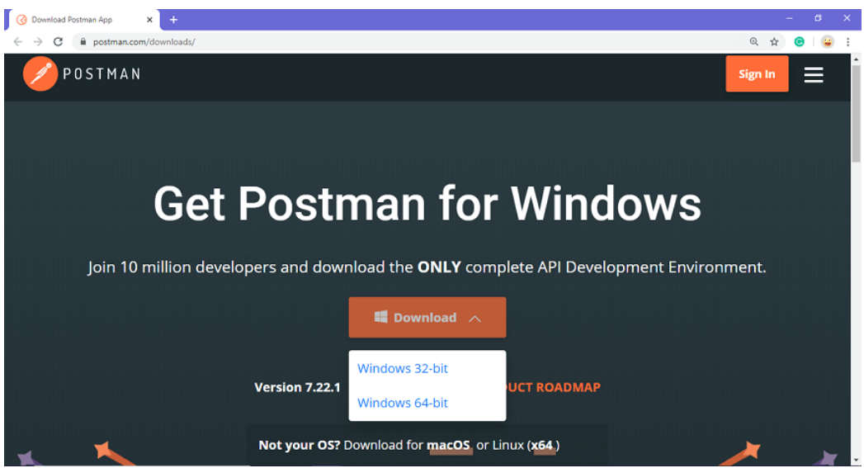

**Step-2: For downloading the app for Windows, click on the download button and select the particular version. I opted for the 64-bit version. If you are using a 32-bit OS, you can choose the 32 bit, as shown in the above image.**

**Step-3: You can check the download progress on the bottom left if you are using the Chrome browser. Once the .exe file is downloaded, you need to install the application, as shown in the below image.**

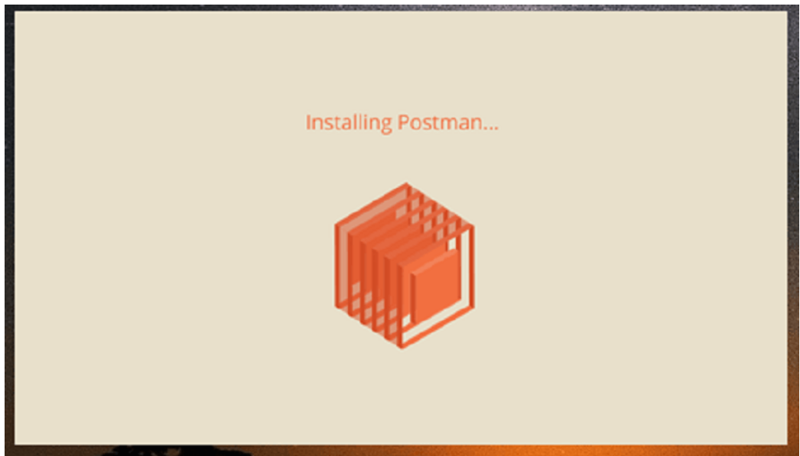

**Step-4: Once the installation completes, you will be redirected to a window as shown in the image where you can click on Stop signing in and take me straight to the app (as this app can also be used without logging in) or otherwise you will get a new window to sign up.**

**It is better to create an account as this will help you to save the work you do within the Postman, and with this, you won't lose any work.**

**Step-5: Create your account with all the required details, or you can also signup with Google, as shown in the image.**

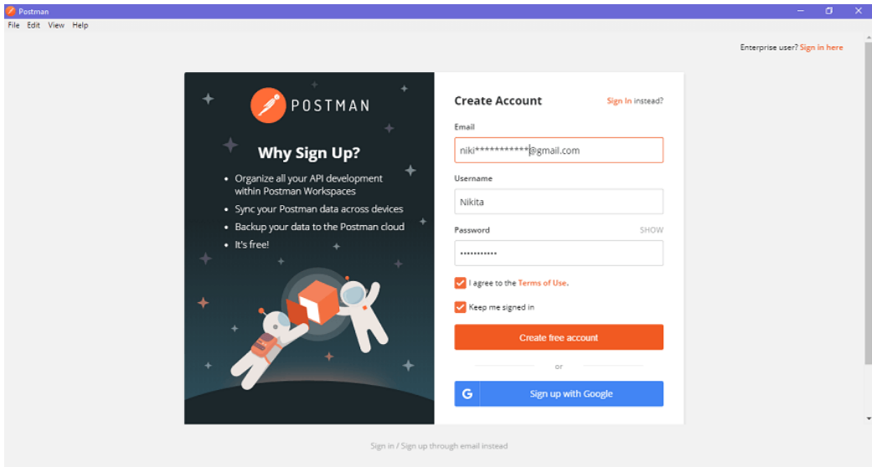

**Step-6: After signing in, select the workspace tools as per your requirement, and then click on, continue to get the startup screen.**

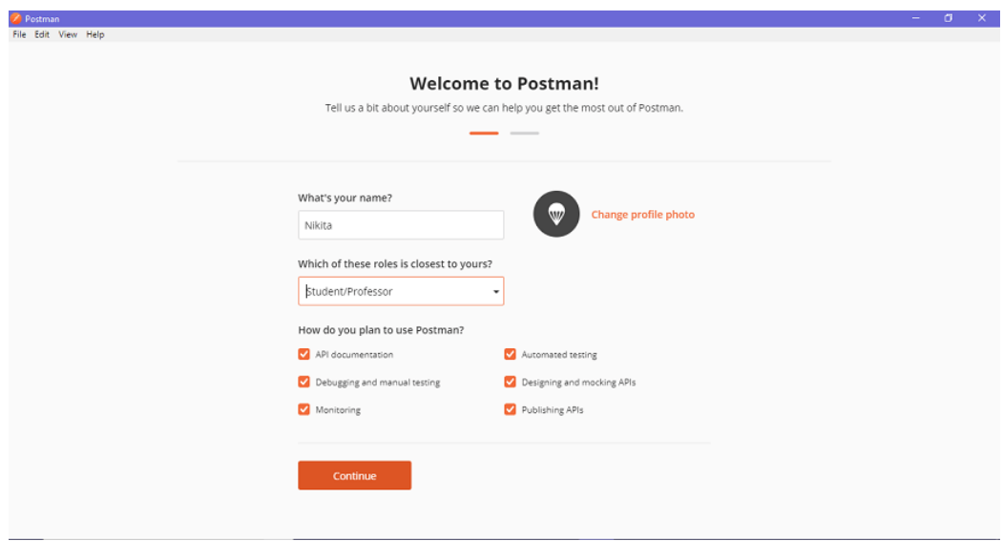

**Step-7: You will see the following page, and then you are ready to use Postman.**

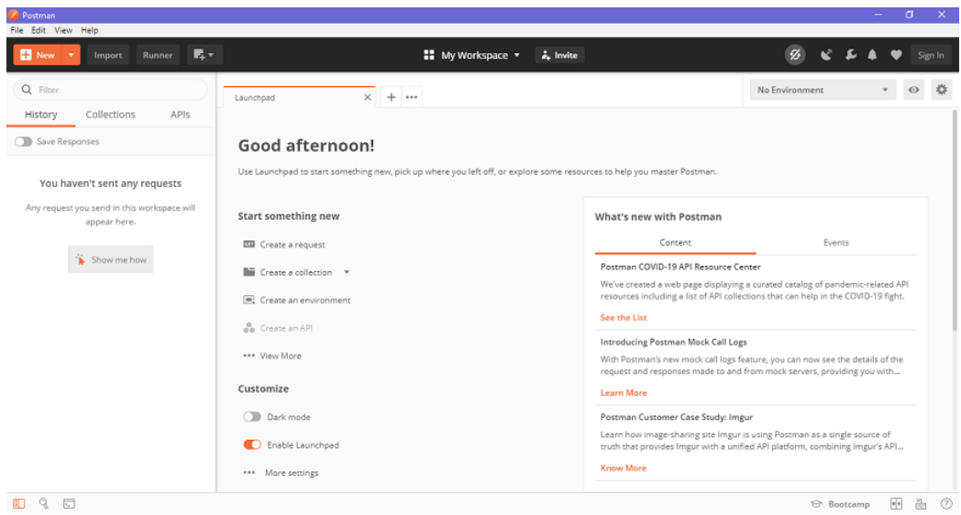

### Steps to update the Postman

* **You will receive a notification in your Postman app if any update is available.**
* **To download or install the latest update, click on the Settings icon, as shown in the image below, go to Settings>Update.**

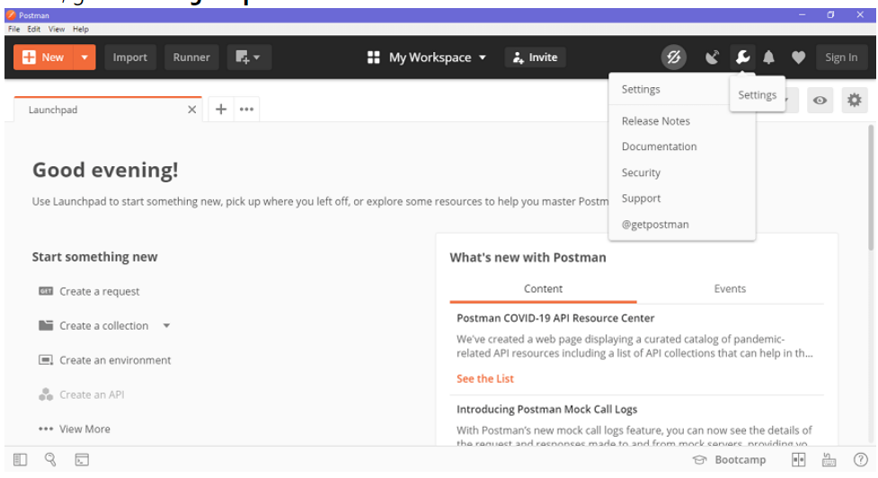

**You can change the update settings by enabling the settings of automatically downloading major updates, as shown in the image below.**

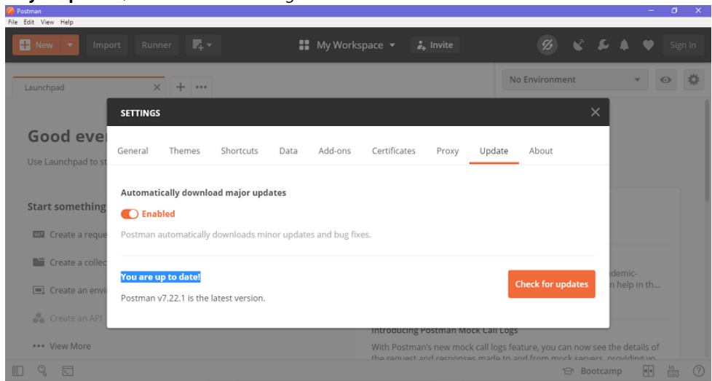

* **You can also check for the latest updates by clicking on Check for updates, which will show you if any new update is available.**
* **You will have to select the update option to download and install the latest update. When the download is complete, you will see a notification asking you to restart the app to install the updated features.**
* **It automatically downloads minor updates and bug fixes.**

## Introduction to HTTPRequest and HTTPClient

* **An HTTPRequest can be used to send** [**requests**](https://docs.oracle.com/en/java/javase/12/docs/api/java.net.http/java/net/http/HttpRequest.html) **and retrieve their** [**responses**](https://docs.oracle.com/en/java/javase/12/docs/api/java.net.http/java/net/http/HttpResponse.html)
* **HTTPRequest are messages which are sent by the client or user to initiate an action on the server. The first line of the message includes the request message from the client to the server, the method which is applied to the resource, identifier of the resource, and the protocol version.**

<https://docs.oracle.com/en/java/javase/12/docs/api/java.net.http/java/net/http/HttpClient.html>

|  |
| --- |
| **import** java.io.IOException; **import** java.net.URI; **import** java.net.http.HttpClient; **import** java.net.http.HttpRequest; **import** java.net.http.HttpResponse;  **public** **class** **API** {   **public** **static** **void** **main**(String[] args) **throws** IOException, InterruptedException {   var url = "https://api.github.com/users/marvel2950";  var request = HttpRequest.newBuilder().GET().uri(URI.create(url)).build();  var client = HttpClient.newBuilder().build();  var response = client.send(request, HttpResponse.BodyHandlers.ofString());   System.out.println(response.statusCode());  System.out.println(response.body());  } } |

*****

## What is maven ?

**Maven is a powerful project management tool that is based on POM (project object model). It is used for projects build, dependency and documentation.**

## Problems without Maven

* **Adding set of Jars in each project**
* **Creating the right project structure**
* **Building and Deploying the project**

How does maven help ?

* **It is easy to build**
* **It has uniform build process (maven project can be shared by all the maven projects)**
* **It provides project information (log document, cross referenced sources, mailing list, dependency list, unit test reports etc.)**
* **It is easy to migrate for new features of Maven**

Maven Project Setup

Download IntelliJ  
<https://www.jetbrains.com/idea/download/#section=windows>

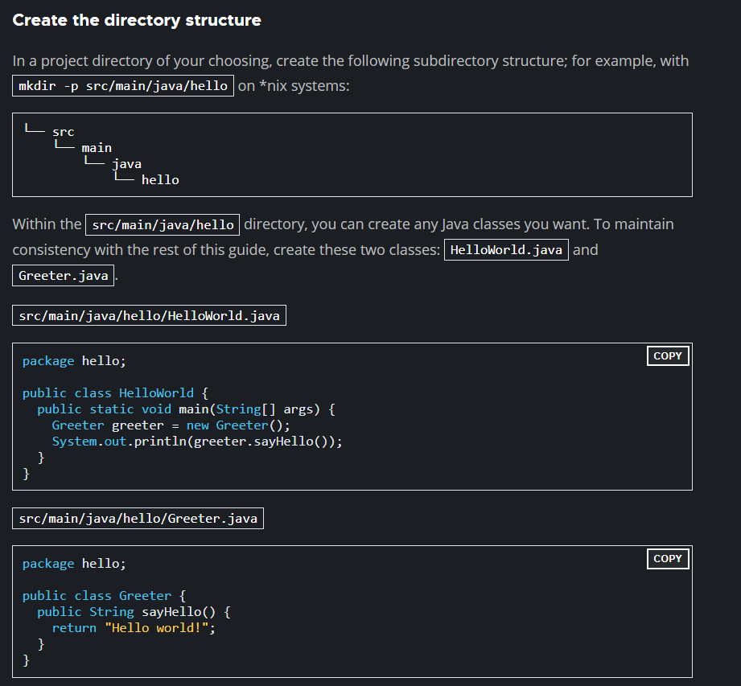

[https://maven.apache.org/download.cg](https://maven.apache.org/download.cgi)i  
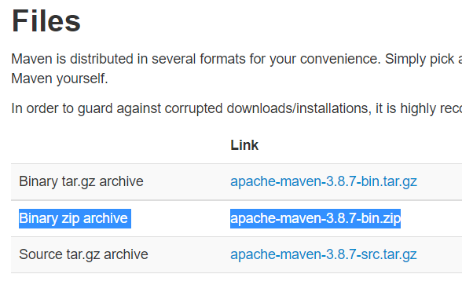

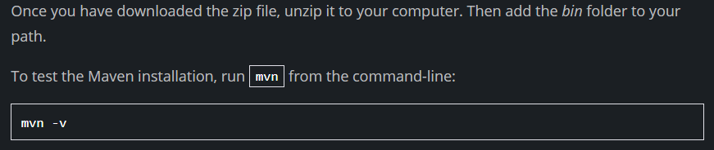

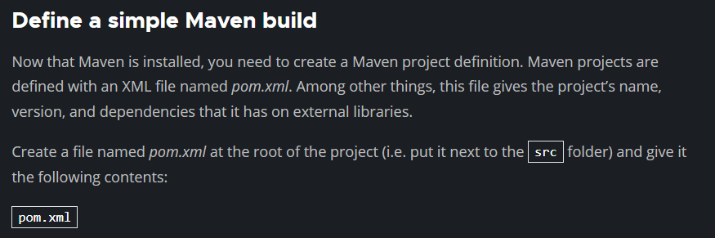

|  |
| --- |
| <?xml version="1.0" encoding="UTF-8"?> <project xmlns="http://maven.apache.org/POM/4.0.0" xmlns:xsi="http://www.w3.org/2001/XMLSchema-instance"  xsi:schemaLocation="http://maven.apache.org/POM/4.0.0 https://maven.apache.org/xsd/maven-4.0.0.xsd">  <modelVersion>4.0.0</modelVersion>   <groupId>org.springframework</groupId>  <artifactId>gs-maven</artifactId>  <packaging>jar</packaging>  <version>0.1.0</version>   <properties>  <maven.compiler.source>1.8</maven.compiler.source>  <maven.compiler.target>1.8</maven.compiler.target>  </properties>   <build>  <plugins>  <plugin>  <groupId>org.apache.maven.plugins</groupId>  <artifactId>maven-shade-plugin</artifactId>  <version>3.2.4</version>  <executions>  <execution>  <phase>package</phase>  <goals>  <goal>shade</goal>  </goals>  <configuration>  <transformers>  <transformer  implementation="org.apache.maven.plugins.shade.resource.ManifestResourceTransformer">  <mainClass>hello.HelloWorld</mainClass>  </transformer>  </transformers>  </configuration>  </execution>  </executions>  </plugin>  </plugins>  </build> </project> |

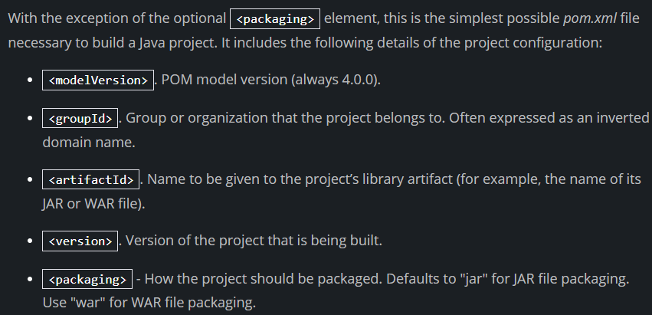

<https://spring.io/guides/gs/maven/>